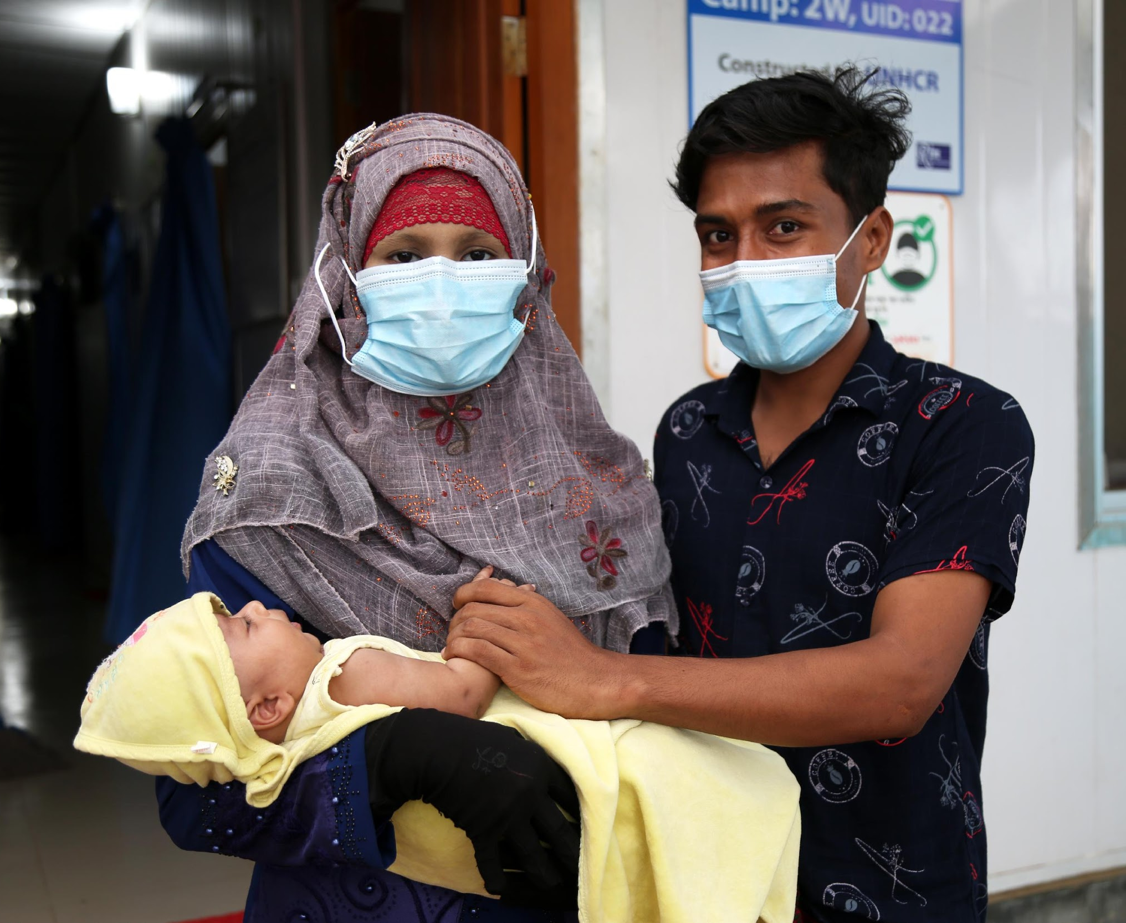
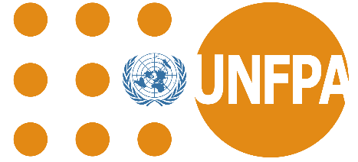

UNFPA BANGLADESH
SITUATION REPORT

UNFPA BANGLADESH EXTERNAL SITREP
ROHINGYA HUMANITARIAN RESPONSE PROGRAMME COX’S BAZAR
April - May - June 2021

A young couple after receiving Sexual and Reproductive Health services (antenatal, postnatal, family planning counselling) from one of UNFPA supported health facilities. UNFPA Bangladesh/Fahima Tajrin

SITREP: April - June 2021
SITUATION OVERVIEW
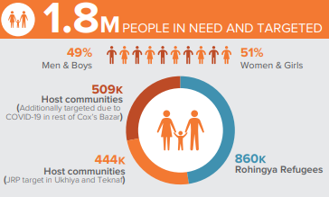
UNFPA is the lead agency of sexual and reproductive health and rights [SRHR] and gender-based violence [GBV] providing services to Rohingya refugees in Cox’s Bazar. About 855,000 Rohingya refugees currently reside in 34 formally established camps within Cox’s Bazar District. Living conditions in the camps are highly congested resulting in security and protection issues as well as accessibility to basic services including SRHR care.

COVID 19 update among Rohingya Refugees and Host Population according to WHO [as of 30th June 2021]: As of 30th June 2021, 103,415 host community individuals and 48,773 Rohingya refugees were tested in Cox’s Bazar. The test positivity for the host was 10.1% with 10,337 positive cases and for the Rohingya refugees the test positivity was 3.6% with 1,775 positive cases. The total lockdown was announced on July 1st 2021 and all activities, facilities, movement, registration and services of GOs/NGOs/INGOs and UN agencies are postponed in the camps except: a) Health and nutrition facilities and services, b) Food carriage, distribution and related services, c) LPG carriage, distribution and related services.

RESPONSE HIGHLIGHTS

SEXUAL REPRODUCTIVE HEALTH AND RIGHTS [SRHR]
Programme:
- In April - June 2021, a total of 27,724 Family Planning visits, 18,905 Antenatal Care [ANC] visits, 1.923 Facility Based Deliveries [FBD] attended by Skilled Births Attends [SBA] and 4,596 Postnatal Care [PNC] visits were seen across the UNFPA supported health facilities.
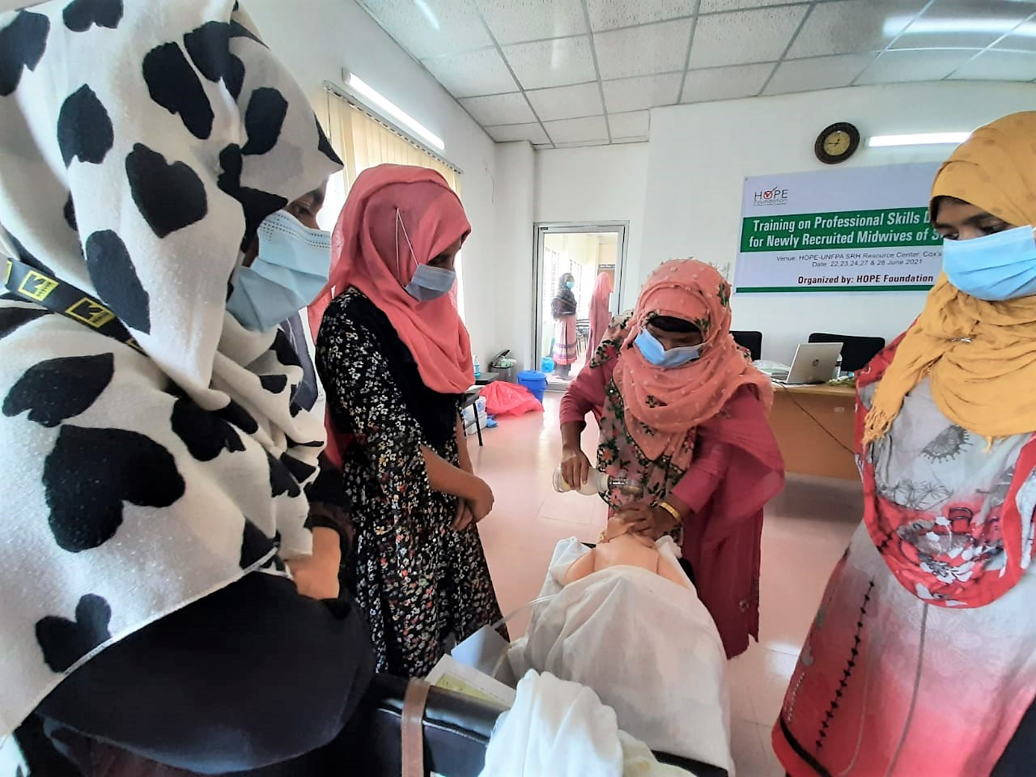
- Community Health Workers (CHW) [456 Female and 16 Male] deployed and supported by UNFPA undertook SRHR information dissemination activities including family planning information as well as health messages related to COVID-19 measures.
Newly recruited midwives attending skill development training and learning essential maternal and newborn health care skills. ©UNFPA Bangladesh

- CHWs reached 269,953 members of the Rohingya refugees and host communities, including adolescents. In addition, a total of 20 Reproductive Health Awareness Groups [RHAG] meetings were held for women, adolescent girls and community gatekeepers such as Majhis, influential members, reaching out to 429 [all female] community members with key messages and information.
- Two [2] UNFPA International Midwifery Mentors undertook 51 midwifery mentoring visits to UNFPA supported health facilities and to Cox’s Bazar Sadar district hospital, reaching out to 142 midwives and covering areas such as Helping Babies Breathe, stabilization and management of emergencies (PPH, Eclampsia and Birth asphyxia), use Non-Pneumatic Anti-Shock Garments (NASG) etc.
- Four [4] virtual sessions were held on identification and repair of genital tract trauma, management of Eclampsia and Postpartum Hemorrhage and a management of pre-labour rupture of membranes [PROM] and on syndromic management of STIs. A total of 11 Midwife Supervisors [all female] attended the sessions and cascaded the training to the midwives under their supervision, across 23 health facilities.
- Mobile Medical Teams [MMT] deployed by UNFPA reached 1,061 women of reproductive age [WRA] including 545 pregnant women; and 338 Family Planning clients from the fire affected camps #8E, #8W and #9 in Ukhiya between 22 March – 22 May 2021, following the successful contribution the midwifery outreach team decommissioned by 22 May 2021. Two [2] UNFPA supported facilities received and provided SRHR services to client referrals from the Mobile Medical Teams [MMT]. As of June, at least 516 clients referred from the fire affected camps had received SRHR services at the UNFPA-supported facilities. In addition, Community Health Workers CHWs] reached 93,778 [Female 81,749: Male 12,029] community members, including 17,099 adolescents in the two [2] affected camps, with information and awareness on SRHR.
Coordination:
- A total of 101,324 Family Planning visits, 78,857 Antenatal Care [ANC] visits, 5,222 Facility Based Delivery attended by Skilled Births Attends [SBA] and 16,726 Postnatal Care [PNC] visits were conducted across the SRH Working Group facilities in Ukhia and Teknaf Upazilas in Cox’s Bazar.
- UNFPA also procured and distributed Reproductive Health Kits, Mama Kits and other SRHR commodities and supplies to Government of Bangladesh facilities as well as SRH Working Group Partners.

GENDER BASED VIOLENCE IN EMERGENCIES [GBViE] - PREVENTION AND RESPONSE
- A total of 28 Women Friendly Spaces (21 in camps and 7 in Host communities) were operational with comprehensive GBV case management services, psychosocial support and lifesaving emergency referrals. Moreover, integrated SRHR services were provided by midwives including family planning and clinical management of rape for survivors.
- Two new Women Friendly Spaces were opened in Camp 6 (April) and in Camp 22 (June) as part of the World Bank Funded Emergency Multi Sector Rohingya Response Project (EMCRP) in collaboration with the Local Government Engineering Department (LGED).
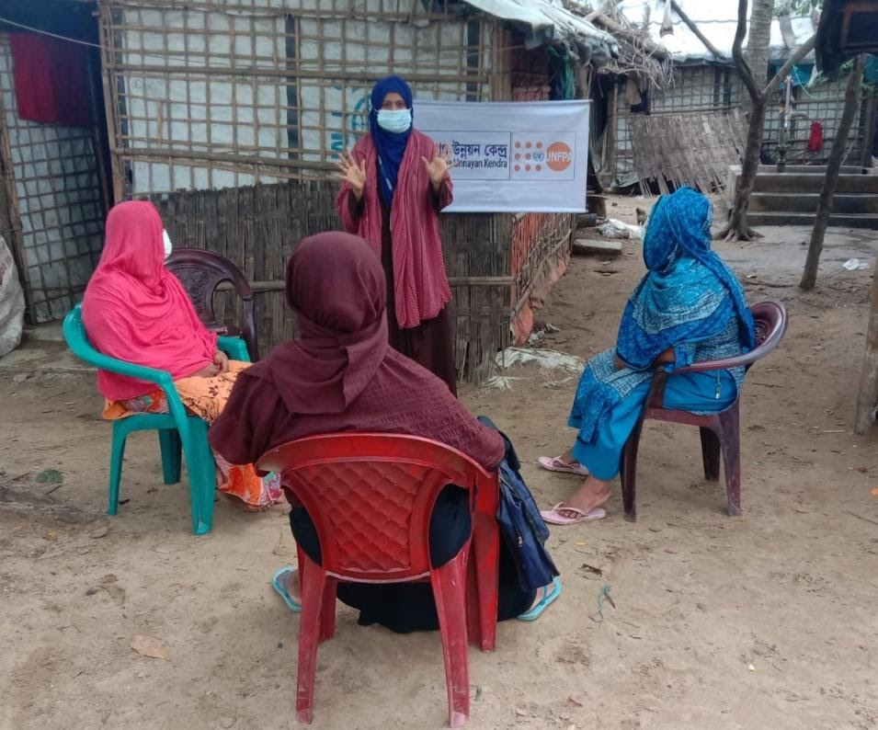
- Mask making activities continued in WFS and a total of 951 reusable cloth masks were produced by women community volunteers.

Amidst the lockdown social mobilizers continued GBV and Covid-19 awareness raising activities in front of households. ©UNFPA Bangladesh

- Following the lockdown imposed in mid-April, women volunteers of the Women Led Community Centers and Women Friendly Spaces conducted 1,263 sessions of door to door visits and one to one sessions on Covid-19 preventive measures and GBV referral pathways.
- UNFPA’s GBV programme provided Psychological First Aid (PFA) sessions to 1,741 fire-affected and displaced refugees by 44 trained female caseworkers under the technical guidance of the UNFPA/ Mukti Cox’s Bazar Mental Health Psycho Social Support (MHPSS) team.
- UNFPA distributed 1,280 dignity kits to women and girls affected by the devastating fire in Camp 9 and 8E.
- UNFPA distributed 1,750 sarees to women in the host community of Ukhiya and Teknaf in June. A beneficiary mentioned; ‘we are glad to receive the sharee, it has been a long since we received something new for us during this covid situation’Toiyoba, Palongkhali WFS

GENDER BASED VIOLENCE Sub-Sector
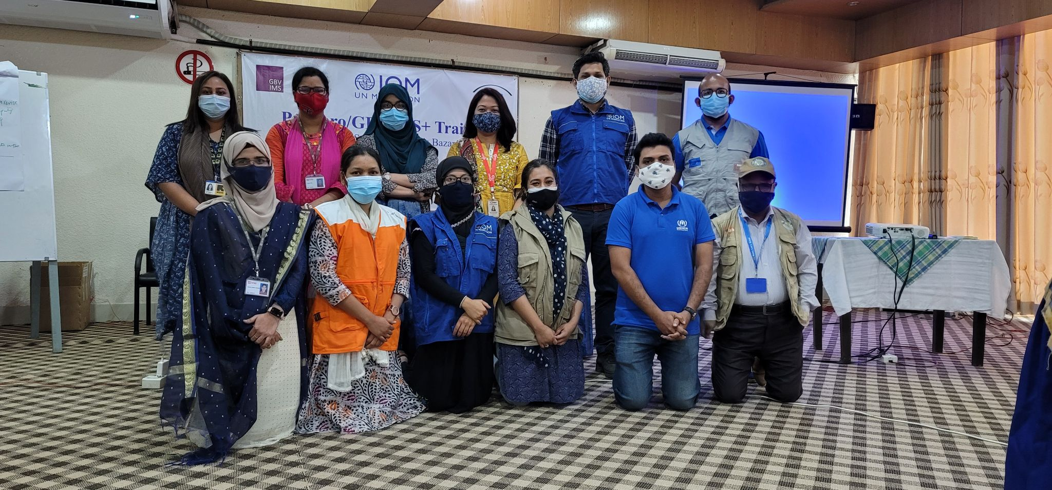
- For the capacity building of GBV sub-sector partners a GBVIMS+ trainings in two separate 3 days’ sessions was conducted for 25 participants from 5 partner organization. A number of webinars for GBV specialists and non-GBV specialists to raise awareness about GBV and GBVIMS with 30 participants, training needs assessment with GBV SS partners to identify MHPSS training needs were also conducted. A total of 50 GBVSS members participated in the MHPSS WG three sessions on self-care.
Participants from one of the trainings facilitated on GBVIMS+ which will help build the capacity of new users. ©UNFPA Bangladesh

ADOLESCENTS AND YOUTH [A&Y]
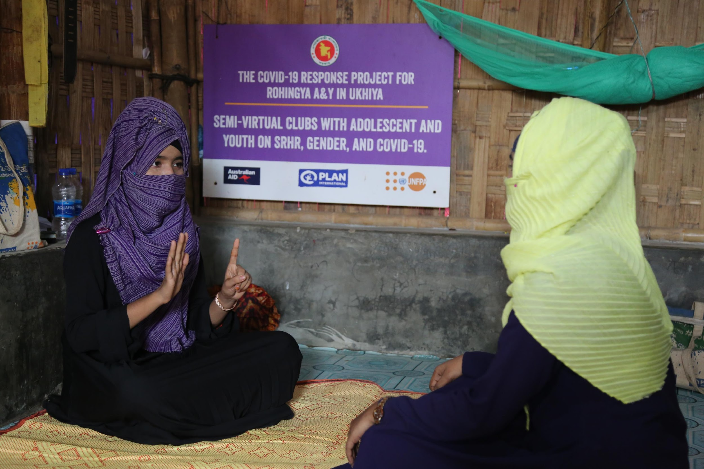
- Through Girl Shine programming, 600 adolescent girls, 537 from Rohingya camps and 63 from host communities, attended home-based sessions on ASRHR, GBV, gender and COVID-19. 136 parents and caregivers, 40 mothers/female caregivers and 96 fathers/male caregivers, attended the Caregivers Support programme in both host communities and refugee camps. 10 male Youth Mentors received an online training on the male caregiver’s curriculum.
One of the adolescents in UNFPA’s semi-virtual club explaining the steps of hand washing to her peer. ©UNFPA Bangladesh

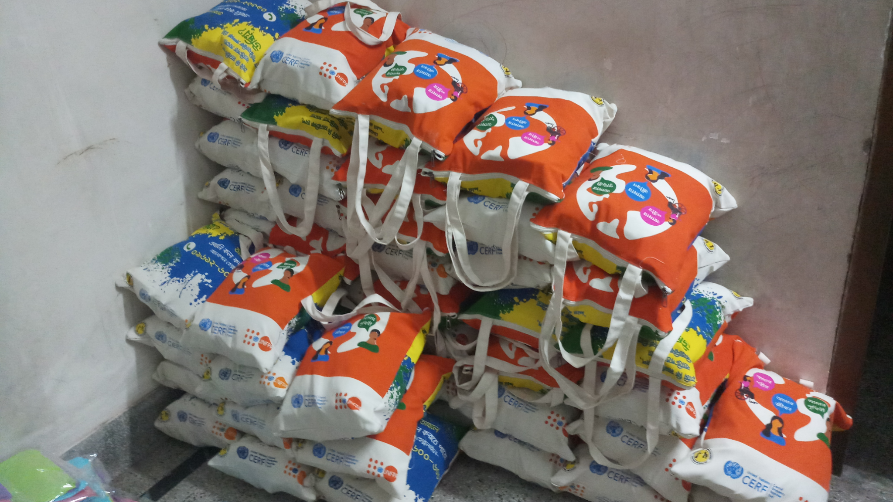
- As part of the Champions of Change programme, 10 CoC officers received training on life skills education, ASRHR, and gender. 19 CoC facilitators were recruited to facilitate the life skills training with the adolescent boys in camps and host communities.
Menstrual health management kits procured and pre-positioned to be distributed to adolescent girls ages 10 - 19 years in surrounding host communities. ©UNFPA Bangladesh

- Through the CERF Global GBV Pilot, 29 adolescent girls, 136 adolescent boys, 14 male caregivers, and 2 female caregivers utilize the Rohingya Alapone Helpline (remote MHPSS counselling). 1,125 menstrual hygiene management kits were procured and pre-positioned targeting adolescent girls living in the surrounding host communities of Cox’s Bazar. 12 Alapon Live Sessions were held on local radio in Cox’s Bazar district and received 77 calls from adolescent boys and girls and 38 from male and female caregivers.
Coordination
- The YWG and Food Security sector organized two monthly meetings and two ad-hocs meetings of the Skills Development Technical Working Group to operationalize the Skills Development Framework in the field.

COMMUNICATIONS
International Day of the Midwife celebrated on 5 May 2021
To mark the International Day of the Midwife, a story on midwifery mentoring was published on the website, along with Facebook and Twitter to promote the work of midwifery in Cox’s Bazar, in the refugee and host communities.
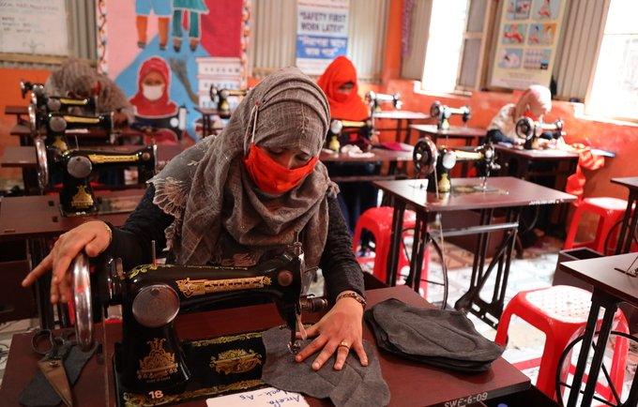
Menstrual Hygiene Day celebrated on 28 May 2021
A women making reusable sanitary pads in a Women Friendly Space (WFS). ©UNFPA Bangladesh

- Rohingya women produce sanitary pads in Cox's Bazar, find on Facebook, Twitter
- Women and girls can understand my pain as they face the same thing
- Accompanying girls in the journey to womanhood, find on Facebook, Twitter

World Refugee day celebrated on 20 June 2021
On the occasion of World Refugee Day 2021, UNFPA Bangladesh paid tribute to the resilience, courage, strength and determination of Rohingya refugees in building their lives anew. Under the theme of “Together We Heal, Learn and Shine” - calling on communities and governments to include refugees - in health care, education and sport
UNFPA Global HQ published a Cox’s Bazar story on parenthood in the Rohingya camps
The story was also published on the: UNFPA Bangladesh website, Facebook and Twitter
Another story Leading the way to help Rohingya adolescents heal, learn and shine again was published on Bangladesh website and also shared via Facebook and Twitter.

FUNDING REQUIREMENTS - 2021
Donors during the reporting period: Australian High Commission, BPRM, Canada, CERF, FCDO-UK Foreign Commonwealth and Development office, Friends of UNFPA, Japan, New Zealand, Norway, Republic of Korea, Sweden.

Funding requirements:
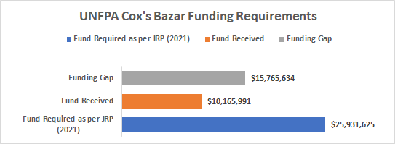

KEY CONTACTS
UNFPA Bangladesh Core Response Team | Asia Pacific Regional Office, Bangkok
Dr. Asa Torkelsson, Representative, torkelsson@unfpa.org  Eiko Narita (PhD), Deputy Representative, narita@unfpa.org  Ms. Roselidah Raphael, Head of Sub-Office, rraphael@unfpa.org | Dr. Tomoko Kurokawa,  Regional Humanitarian Advisor, kurokawa@unfpa.org  Mr. Klaus Beck, Programme Advisor  beck@unfpa.org  Ms. Isabella Thafvelin, Humanitarian Officer, thafvelin@unfpa.org

Joint Response Plan (JRP), 2020 Inter Agency Coordination Group, Cox’s Bazar, Bangladesh

