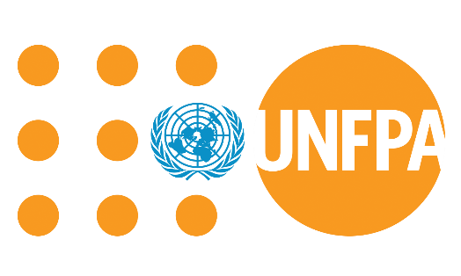

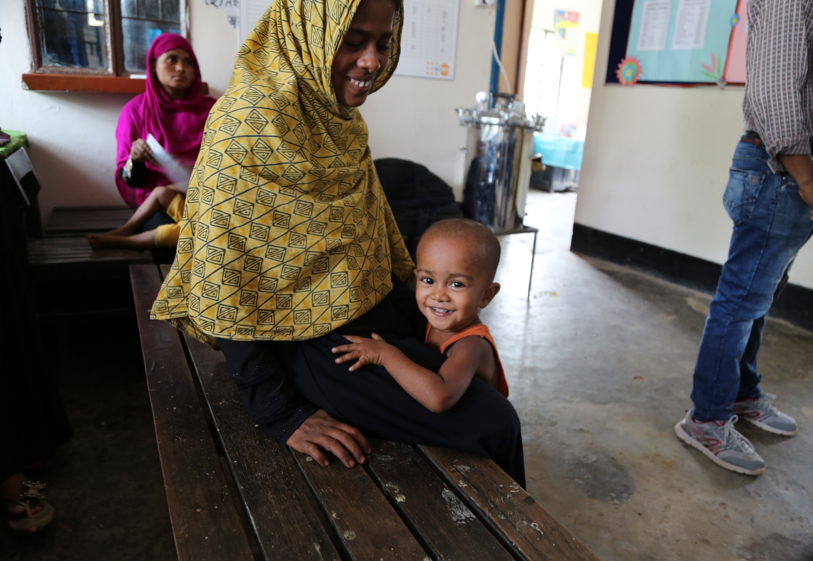

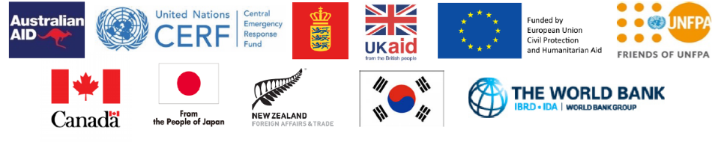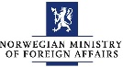

**SITUATION REPORT  
 ROHINGYA HUMANITARIAN RESPONSE PROGRAMME COX’S BAZAR**

**BI-MONTHLY AUGUST-SEPTEMBER 2019**

The

Th

**SITUATION OVERVIEW**



**1,242,400**1people are in need



**304,388**1 women & girls of reproductive age

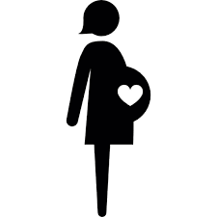

**29,818**1pregnant women

* 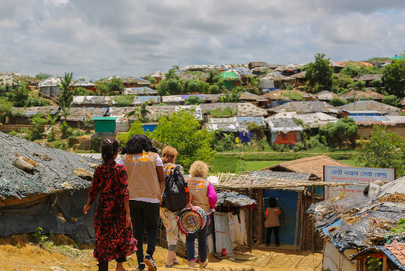Since August 2017, more than 745,000 Rohingya refugees have fled into Cox’s Bazar, Bangladesh after decades of systematic discrimination, statelessness and targeted violence in Rakhine State, Myanmar. Around 1,242,400 people are in need and targeted[1]. Most refugees are **women and girls (52%)** with 29,818 pregnant women (2.4%) and 304,388 women and girls of reproductive age (24%).
* There was a repatriation exercise that was on 22nd August organized by the Government of Bangladesh.
* According to report of UNDSS (United Nations Department of Safety and Security) on September 10, 2019, multiple landslides were reported in the camp area, especially in Teknaf area triggered by nonstop rain in Cox’s Bazar.

**UNFPA RESPONSE HIGHLIGHTS (AUGUST – SEPTEMBER 2019)**

* Food supplement voucher programme was implemented and analysis showed that 48% increase in ANC service uptake and 14% increase in facility-based delivery.
* Two batches of 4-day Clinical management of Rape (CMR) training were conducted targeting health service provider.
* Two new WFSs has been established and started providing services in the host community settings, another one is under construction in Leda camp area.
* Media Workshop on upholding dignity in GBViE with 23 journalists from local and national print, electronic and online media houses was organized to orient the media personnel on Basic GBV as well as analyze media reports together in the perspective of GBV guiding principles and survivor centered approach.
* 400 Adolescent boys were trained to perform 24 theatres for development (TfD) shows on gender issues and gender-based violence.

**SEXUAL AND REPRODUCTIVE HEALTH AND RIGHTS (SRHR)[2]**

* One-day workshop onEvidence Based Practice in normal labour was organized to orient five female medical officers who are based in the health facilities, to align with practice that national midwives are mentored.
* Integration services continued at 19 Women Friendly Spaces (WFS) providing SRHR services and at 20 health facilities linking psychological first aid (PFA) and linking with the other services to women and girls who are at risk of Gender Based Violence (GBV). **3,948 SRHR** services are provided at WFS and **13,054 women and girls** are supported byWomen Girls Support Officer (WGSO**)** in the health facilities.
* To expand the integration effort and strengthen the partnership with the other UN agency, **a midwife was posted in UN Women Multi-Purpose Center** to integrate SRHR services in the center.
* A pool of trainers consists **17 supervisors/managers (8 females, 9 male)** of community health workers (CHWs) are developed on Comprehensive SRHR training and they trained total **300 CHWs (all female)** as a part of their roll out plan.
* 2 Paramedics were recruited and trained as **Paramedic mentor to ensure the mentoring in the facility** on comprehensive FP, MR and PAC services. 9 paramedics are trained on 14 days Comprehensive Family Planning (FP), Menstrual Regulation (MR) and Post Abortion Care (PAC) training.

**GENDER BASED VIOLENCE IN EMERGENCIES (GBViE) - PREVENTION AND RESPONSE[3]**

|  |  |  |  |
| --- | --- | --- | --- |
| **SERVICE PROVIDED2** | | **PEOPLE REACHED2** | |
|  | **35**  health facilities with  UNFPA support |  | **1,152**  UNFPA facility based safe deliveries |
|  | **23**  functional UNFPA supported health facilities provide 24/7 EmONC and Comprehensive SRHR services |  | **21,164**  Population reached with Family Planning  services |
|  | **40**  service delivery points provide clinical management of rape (CMR) services |  | **65,750**  women and girls are accessing 22 Women  Friendly Spaces (WFS) |
|  | **111**  reproductive Health kits are provided |  | **10,990**  People reached through GBV social mobilization |
|  | **10**  Women Led Community Centers (WLCCs) with  UNFPA support |  | **855**  adolescent girls reached through Girl Shine Programme |

* 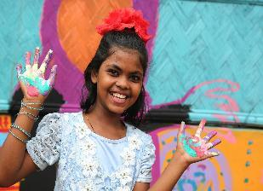Developed strategic plan October- December 2019 which includes self-care sessions, case management peer reviews, implementation of Psychosocial Support (PSS) activities and basic PSS training for implementing partner (IP) Gana Unnayan Kendra (GUK) social welfare staff and IOM case workers.
* **1,041** women and girls from 20 WFSs and 10 WLCCs trained on Art and Craft in different trades including hand-made jewellery making, book cover making, basic applique, tie-dye and block-batik.
* Facilitated a training on GBV Basics with 26 protection officers, social workers and community protection officers of Handicap International.
* Conducted PSEA orientation for 20 case managers, 106 case workers, 3 senior case managers and 1 project coordinators.
* Developed a module on Theatre for Development (TFD) and 5 culture -specific scripts on social issues as a part of social mobilization activities.
* A client satisfaction survey with WLCC graduates has been conducted in order to get feedback on the given services and trainings from the participants across all the WLCCs.

**ADOLESCENT AND YOUTH**

* 8,550 adolescent boys – 1,350 from the host community and 7,200 from the refugee camps - graduated from Champions of Change (CoC) and participated in a celebratory quiz competition and closing ceremony to mark the occasion.
* 400 adolescent boys from across 9 camps and 1 host community, staged theatre shows on gender, gender-based violence, and child protection in their specific locales. Of the 400 adolescent boys, 360 were from the Rohingya community and 40 were from the host community.
* 855 adolescent girls - 765 from the camps and 90 from the host community - benefiting from structured life skills sessions. These sessions are being rolled out across UNFPA’s 19 Women-Friendly Spaces.
* All 38 adolescent girls - 34 from the refugee camps and 4 from the host community - who volunteered to co-facilitate Girl Shine sessions as mentors commenced their duties as volunteer mentors during this reporting period.

**FUNDING REQIREMENTS**

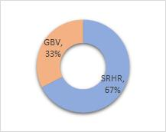**Donors in the reporting period:** Japan, DANIDA Denmark, European Civil Protection & Humanitarian Aid Operations – ECHO, CERF, DFID-UK, Sweden, World Bank, Australian High Commission, Republic of Korea, New Zealand, Canada, Friends of UNFPA, Women’s Refugee Commission.

**The total JRP funding requirements for SRHR and GBV sectors is USD 20,000,000.**

Sector wise funding requirements:

**SRHR:** 13,500,000 USD, **GBV**: 6,500,000 USD

The Gap in funding for JRP 2019 is **6,660,674.74 USD**

1. Joint Response Plan Report, 2019 extracted from the website: [https://www.humanitarianresponse.info/en/operations/bangladesh/](https://www.humanitarianresponse.info/en/operations/bangladesh/infographic/2019-joint-response-plan-rohingya-humanitarian-crisis-snapshot) [infographic/2019-joint-response-plan-rohingya-humanitarian-crisis-snapshot](https://www.humanitarianresponse.info/en/operations/bangladesh/infographic/2019-joint-response-plan-rohingya-humanitarian-crisis-snapshot) on 1 April 2019
2. Data extracted from Kobo Data Sheets (UNFPA SRH & GBV Internal Information Management System); Procurement Register; Regular Progress Tracking Record forms of programmes, attendance sheets of implementing partners (IPs), August - September 2019.
3. Data extracted from Kobo Data Sheets (UNFPA SRH & GBV Internal Information Management System); Procurement Register; Regular Progress Tracking Record forms of programmes, attendance sheets of implementing partners (IPs), August - September 2019.